Metadata Format
File Type: The dataset is provided in a comma-separated values (CSV) format which is often used for storing tabular data. They are simple files, lightweight and compatible with most data processing and analysis tools.
Delimiter: Each line represents a single record and fields are separated by commas, which are the delimiters. This format ensures data remains structured and easy to parse by spreadsheet software and programming languages like Excel and R.

Origins: The metadata provided comes from a collection of Shiga-Toxigenic Escherichia coli genomes sampled from a variety of countries between 2014 and 2019. The data includes information on accession, country or region, year, Shiga toxin subtype, and phage type. Comma-separated values (CSV) files, which originated in the early 1970s, were designed to simplify data storage and sharing. The precursor format, known as Free-form input-output, was defined in 1978, while the term "comma-separated value" and its abbreviation "CSV" were first used in 1983.

The definitions of the key columns describing Shiga-Toxigenic Escherichia coli (STEC) genomes are:
- Accession: A unique identifier for each genome sequence or sample.
- Country & Region: The location where the sample was collected.
- Year: The year the sample was collected.
- Shiga toxin (Stx) subtype: The specific toxin subtype present.
- Phage Type (PT): The type of bacteriophage associated with the strain.

Figures and Legends
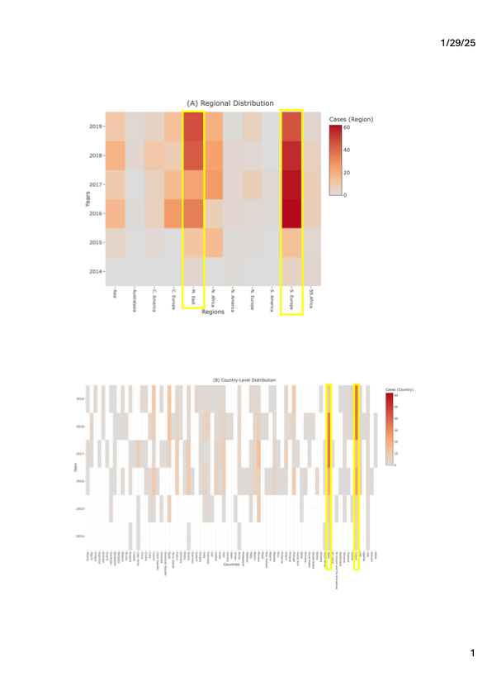
Figure 1: Heatmap of Geographic and Temporal Distribution of Shiga-Toxigenic Escherichia coli (STEC) Cases
(A) Regional distribution of STEC samples, illustrating the geographic spread and intensity of cases across broader regions and (B) Country-level distribution, providing a more detailed view of the number of cases reported in specific countries. An interactive version of the figure can be found here ( A and B) which allows for further exploration, displaying details such as the year, number of cases, as statistic calculations of the mean, median, and standard deviation of cases in each region or country. The Regions and countries with the most prevalent cases were boxed in yellow.
file:///Users/sahramusse/Documents/Applied%20Data%20Science%20in%20Biology/Semester%202%20Assessment/Results/heatmap_region.html
file:///Users/sahramusse/Documents/Applied%20Data%20Science%20in%20Biology/Semester%202%20Assessment/Results/heatmap_country.html

Heatmap of Geographic and Temporal Distribution of Shiga-Toxigenic Escherichia coli (STEC) Cases

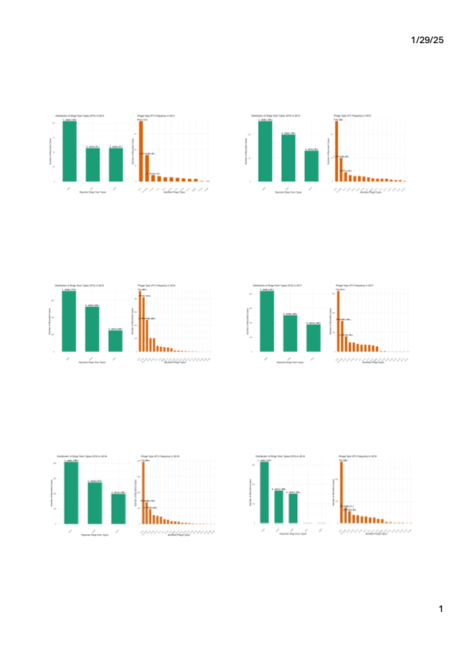
Yearly Distribution of Shiga Toxin Types (STX) and Phage Types (PT)
Figure 2: Each figure presents the distribution of reported Shiga Toxin Types (STX) and Phage Types (PT) for a given year between 2014-2019. The left plot (STX) displays the frequency of different Shiga toxin types identified in cases, while the right plot (PT) shows the distribution of reported phage types. The top three most frequently observed categories in each plot are labelled for better clarity. Data categorized as 'Missing or Unclassified' have been excluded for accurate trend representation.

Data Description
Country and Region
The dataset comprises isolates from multiple countries, with a notable overrepresentation from the Middle East and Southern Europe. The highest case counts were recorded in 2016 (62 cases) and 2019 (45 cases), respectively (Fig. 1). However, the heatmap illustrating distribution within countries indicates that Turkey and Spain are the most dominant regions. This imbalance may distort classification models, as they predominantly learn patterns from these areas while struggling with underrepresented locations. Countries with fewer samples may not provide sufficient data for generalisation, leading to poor classification performance.
Furthermore, even the highest case counts are insufficient to accurately reflect the global distribution of STEC cases, limiting the dataset’s statistical reliability and representativeness. The data in Figure 1 suggest a higher likelihood of STEC cases in these regions; however, a larger sample size and rigorous statistical testing are necessary to confirm whether this pattern is statistically significant rather than a result of random variation.
Despite these limitations, country metadata remains a valuable predictor if appropriate techniques—such as resampling (oversampling rare countries or under-sampling dominant ones) or class-weighted models (which adjust learning emphasis based on class frequency)—are applied to mitigate partiality. Additionally, metadata standardisation should be ensured to maintain consistency in country naming and avoid discrepancies due to variations in labelling.

Years
The dataset spans six years (2014–2019), but the distribution of samples across these years may be uneven. If certain years are overrepresented while others have fewer samples, classification models may learn temporal patterns that do not generalise well to future data. Additionally, changes in diagnostic methods, sampling strategies, or reporting practices over time could introduce inconsistencies. However, the dataset does not account for seasonal trends or outbreak events, making it unclear whether observed temporal patterns are biologically or epidemiologically meaningful. Without this context, it is difficult to determine if time is an appropriate predictive feature or merely a source of noise. Assessing potential systematic shifts in data collection and applying stratified sampling across time periods could help balance the dataset and improve temporal generalisation.

Shiga Toxin
The dataset exhibits a strong imbalance in Shiga toxin (Stx) subtype distribution, with Stx2c being the dominant variant, followed by Stx2a and Stx1a, while Stx1c and Stx2d appear only in 2019. This uneven distribution raises concerns about data representativeness and classification performance. If a model is trained on such imbalanced data, it may disproportionately learn patterns associated with the dominant subtype (Stx2c) while failing to accurately classify the less frequent ones. This could result in poor sensitivity for rare subtypes, which may have distinct epidemiological or clinical relevance.
The late appearance of Stx1c and Stx2d suggests either a true emergence of these subtypes in 2019 or a shift in diagnostic methods, sampling focus, or reporting practices. Without a consistent detection methodology across years, temporal patterns may not be reliable. Statistical tests, such as chi-square or Fisher’s exact test, should be conducted to determine whether these variations are significant or occur by chance.
To enhance data appropriateness for classification, balancing techniques such as Synthetic Minority Over-sampling Technique (SMOTE), under-sampling dominant subtypes, or stratified sampling should be considered. Additionally, systematic biases in data collection should be investigated to ensure that missing or underrepresented subtypes are not a result of inconsistent sampling. If the dataset does not accurately reflect the true prevalence of Stx subtypes, model predictions may be unreliable and should be interpreted with caution.

Phage Type (PT)
The distribution of Phage Types (PT) within the dataset is highly imbalanced, with PT8 being the most dominant across the years, followed by PT 21/28, PT 54, PT 2, and PT 34, depending on the year. Less common PTs, such as PT 46 and PT 90, are underrepresented, which may limit the statistical power of classification models. This imbalance can lead to overfitting toward prevalent PTs, reducing the model’s ability to generalise and accurately classify rare PT. Consequently, the overall reliability of predictions is compromised, particularly for epidemiologically significant but infrequent phage types.
To mitigate this issue, data resampling techniques should be employed, including under-sampling PT8 and oversampling rare PTs to create a more balanced dataset. Synthetic data generation, such as SMOTE, could further enhance model performance for minority classes by improving representation without artificially inflating patterns of dominant PT.

Data Quality and Completeness
In the report, I have omitted samples with missing data to prevent potential biases that could arise from incomplete information. The evaluation of the remaining data suggests that it is generally well-balanced for building classifier models across the different metadata classes. Statistically, the absence of missing data reduces the risk of skewing model results, ensuring that relationships between variables are not distorted. Epidemiologically, the dataset appears to maintain its relevance, as the distribution of available data is representative of the broader trends necessary for accurate classification. This approach ensures both the statistical integrity and the practical applicability of the models.

Conclusion
In conclusion, the dataset exhibits some imbalances in terms of geographical representation, temporal distribution, and metadata classes such as Shiga toxin subtypes and phage types, which may impact the performance of classifier models. The overrepresentation of certain regions, years, and subtypes can lead to models that are biased toward these dominant categories, reducing their ability to generalise across underrepresented ones. While the omission of samples with missing data helps mitigate potential bias, further techniques such as resampling, stratified sampling, and model adjustments are necessary to address these imbalances.

Appendix:
file:///Users/sahramusse/Documents/Applied%20Data%20Science%20in%20Biology/Semester%202%20Assessment/Results/heatmap_region.html

file:///Users/sahramusse/Documents/Applied%20Data%20Science%20in%20Biology/Semester%202%20Assessment/Results/heatmap_country.html

